Nguyễn Phan Nhựt Trường N20DCCN082

**HOMEWORK 2**

**Assignment 1:**

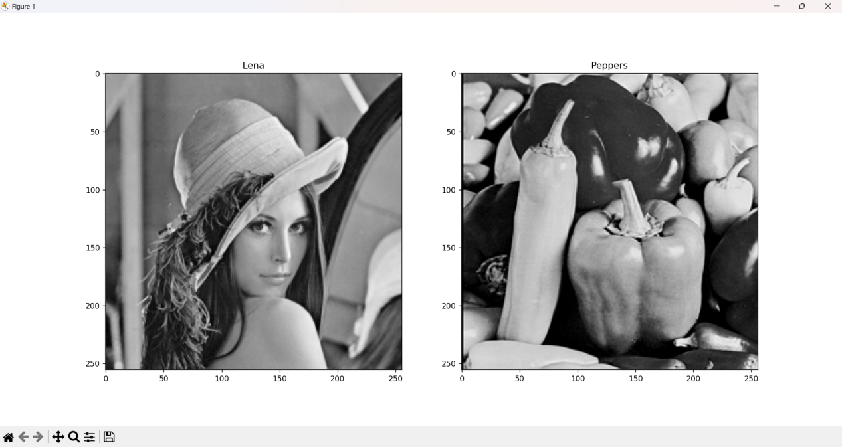

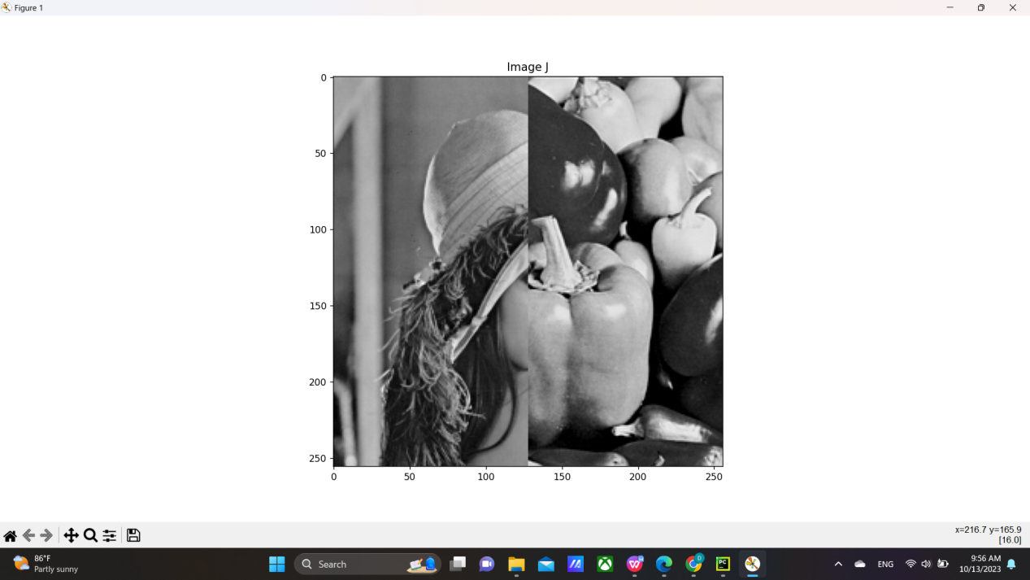

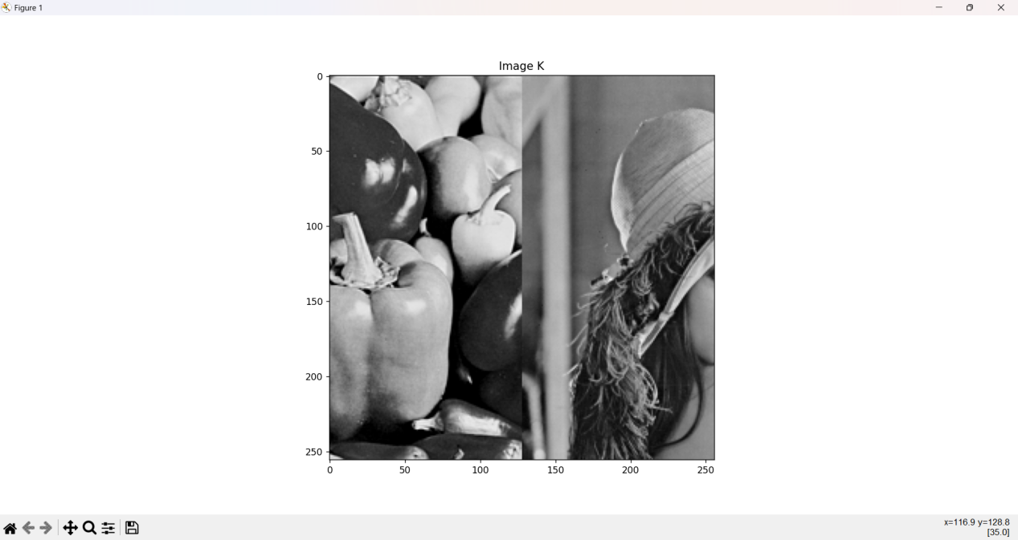

**Assignment 2:**

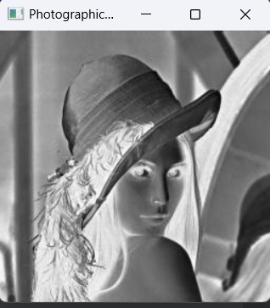

**Assignment 3:**

